**T-Shirts :**

**31**

|  |  |
| --- | --- |
| **Grand** | **10** |
| Black | 8 |
| Navy | 1 |
| Red | 1 |
| **Moyen** | **11** |
| Black | 11 |
| **Petit** | **3** |
| Black | 1 |
| Jade Dome | 1 |
| Purple | 1 |
| **Très grand** | **5** |
| Black | 5 |
| **Très très grand** | **2** |
| Black | 2 |

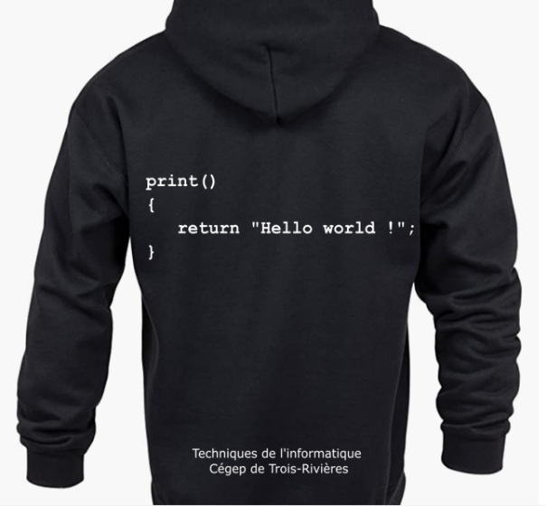**Kangourous :**

**43**

|  |  |
| --- | --- |
| **Grand** | **20** |
| Antiq red cherry | 1 |
| Black | 6 |
| Dark heather | 1 |
| Forest green | 1 |
| Military green | 1 |
| Navy | 4 |
| Purple | 3 |
| Red | 1 |
| Royal | 2 |
| **Moyen** | **8** |
| Black | 1 |
| Dark chocolate | 1 |
| Forest green | 2 |
| Navy | 2 |
| Purple | 1 |
| Red | 1 |
| **Petit** | **2** |
| Black | 1 |
| Royal | 1 |
| **Très grand** | **6** |
| Antiq cherry red | 1 |
| Antique saphir | 1 |
| Black | 1 |
| Navy | 2 |
| Royal | 1 |
| **Très très grand** | **7** |
| Antiq cherry red | 1 |
| Black | 3 |
| Forest green | 1 |
| Purple | 2 |